

Vendor Projection Instructions

Overview
Ace Hardware’s Vendor Projections report is designed to provide visibility into Ace’s projected demand pattern at the article or (article/site) level. The report is updated Monday of each week and accounts for changes to the forecasts, stock status, inventory, on order as well as other variables. The report displays 52 weekly periods of projections as either eaches, dollars, cube &/or weight. Users can view the forecast results based on various triggers (expected receipt window, expected purchase order window, expect outbound demand to retailer window).
The data within the report serves as a guide to the anticipated article demand for each weekly period based on the components that drive our replenishment applications.
The data provided cannot and should not be considered a guaranteed purchase quantity or a commitment to buy as many factors can influence the timing and the actual quantities of an order. It is highly recommended that any planning for promotional items continues to be a collaborative process with the Ace Hardware Inventory and Merchandising teams. Additional purchases required to support promotions; special programs and other events may not always be included in the Projections Report. In addition, as with most forward looking reporting, the accuracy diminishes the further out it is projected; it is recommended that the Projections be run on a regular interval.
It is important to remember that the Projections should be just one component to the overall Supply Chain plan of our Vendor community. To be most effective, Ace recommends that vendors calculate their own projection for Ace’s portion of their business based on historical trends, industry and market conditions, current consumer trends, legislative changes, etc. The vendor’s projection should then be compared to Ace’s projection and significant differences discussed with Ace’s Buying and/or Replenishment team. Once finalized, the projections combined with an adequate safety stock level should be factored into the vendor’s manufacturing production schedules, import buying plans, etc.
By utilizing Ace’s Projection reporting, it is our hope that your company will successfully achieve high vendor first-fill rates to Ace, in turn maximizing your sales potential.

Steps for running a Vendor Projection Report

Steps | Visuals
- Log onto Ace Hardware’s Vendors.com website: http://www.acehardware-vendors.com/

- Click on the E-Tools icon | 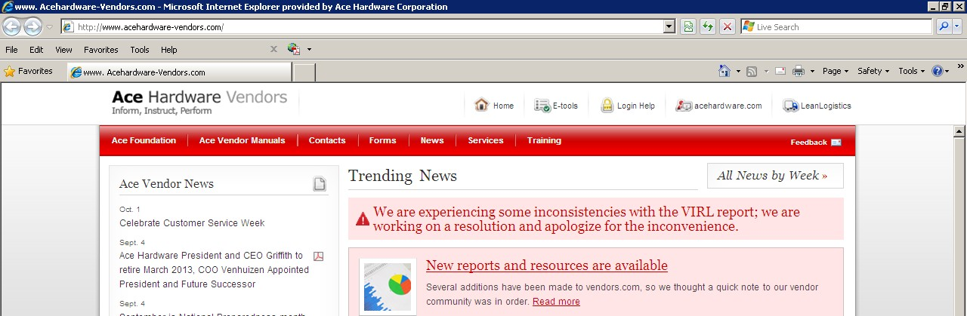
- Log into Ace’s firewall by using your existing ETools user ID and password:  ** New users of ETools must request an ID  Go to www.acehardware-vendors.com/  Click on the login help button  select ID request.  Be sure to indicate both that you are a new user as well as you need access to the Toolbox.  Note: It may take up to 2-5 days to have your request for access processed. | 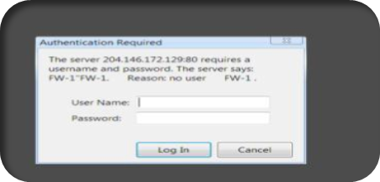
- Select the Tool Box | 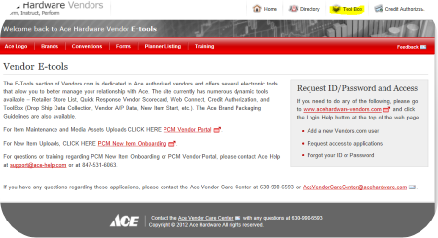
- Logon using your existing vendor ID and password:  ** New users of Toolbox must request an ID  Go to www.acehardware-vendors.com/  Click on the login help button  select ID request.  Be sure to indicate both that you are a new user as well as you need access to the Toolbox.  Note: It may take up to 2-5 days to have your request for access processed. | 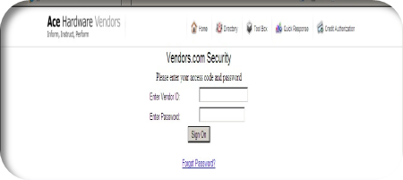
- Select the ADW Reporting on the Toolbox menu and click “I agree” on the next agreement screen. | 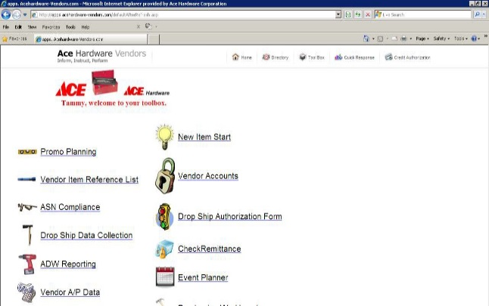
- Under the Product tab, select the W-PROD-V1000 Vendor Projections. | 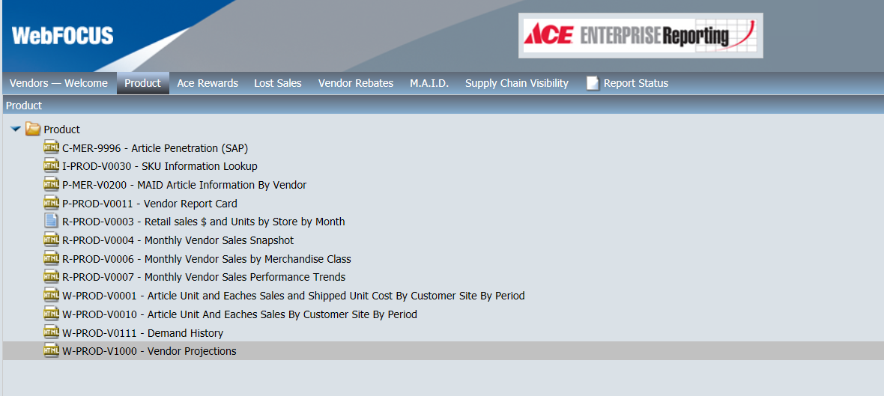
- Select your criteria:  Report Type  - Vendor to Ace (Article) – this will display projections on an item level (all warehouses aggregated)  - Vendor to Ace (Article-Site) – this will display projections at an item-warehouse level.  Aggregation  - Default is weekly increments, with monthly option available. Always note the date range which comprises the month  Values: Leave blank to show demand by expected receipt order window  - Inbound Ace WHSE Receipts- Receipts into the domestic warehouses (RSCs) by delivery week. Both actual open purchase orders and projected purchase orders are included.  - Outbound Ace WHSE Demand – Projected store demand pull from our 14 domestic warehouses (RSCs) by week.  - Inventory - Projected inventory based on the demand projection from our retailers.  - Purchases- Projected purchases into the Ace domestic warehouses (RSCs) by delivery week.  For the suppliers that ship inbound to Ace's Kent, WA, Suffolk, VA, and Laredo, TX RDCs (Import Re-Distribution Centers) these two additional options are available:  - Outbound ACE Imp Dist Ctr. Demand - Demand Pull from our 3 import warehouses (RDCs) to domestic warehouses (RSCs).  - Inbound ACE Imp Dist Ctr. Demand - Receipts into the import warehouses (RDCs) by delivery week. Both actual open purchase orders and projected purchase  - Select a Metric Value: Leave blank to show demand by eaches only  - Export Format: The crosstab by week option will display the report in a “pivoted” format where each week is in its own column.  - The tabular option will display the data in an “unpivoted” format where each item-week or item-site-week combination is in its own row. While this option is easier to manipulate in Excel, it will include more rows of data.  - By default, the export format is set to “crosstab by week and tabular,” where the crosstab version of the report is on the first tab of the workbook, and the tabular version of the report is on the second tab.  - Select I agree & submit: | 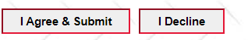
At the Deferred Report Notification screen, click the OK button.  (The report can be named differently for the Report Status tab to help keep track of multiple report runs, but is optional) | 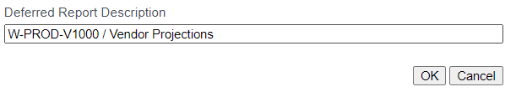  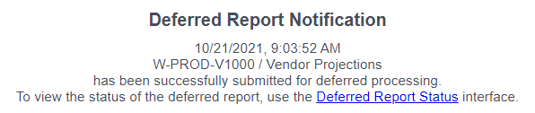
To retrieve the Purchase Projection Report that you just ran:  - Click on the Report Status tab.  - After launching the report, it will transition from a “Queued” status to “Running” to “Completed”.  - Make sure you enable the Refresh of the screen so when the report is finished running, the status will automatically change to “Completed”.  - Once completed, click on the View button to open the report that will be formatted in Microsoft Excel. | 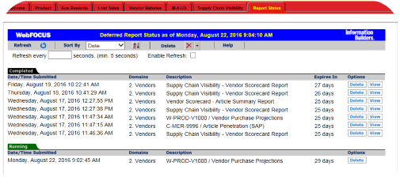
The following is a sample of a Vendor Projection Report.

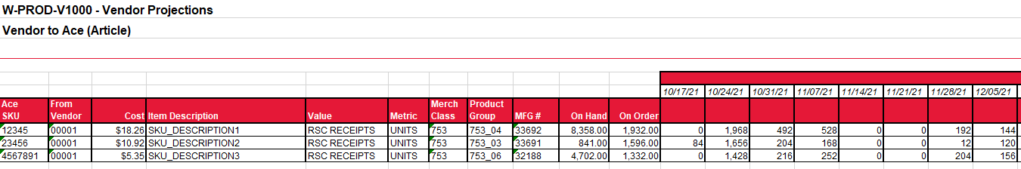
Questions?
***Please note: the receipt projections report shows projected warehouse receipts and not projected shipments. Comparing the Ace receipt projection to actual vendor shipments for that week or month can cause the results to appear skewed due to the differences in the ship date and receipt date.
• It is also important to note that receipt projections may include both open Ace purchase orders as well as projected orders depending on the item. The receipt projection volume is not in addition to current on order, as it is a blend of firm and projected orders.
• If using this data to determine when product would need to be ready to ship, then subtracting your expected transit time from the receipt projection date would be a means to do so. Similarly, if considering your production or manufacturing lead times, then the same approach can be considered.
The nuances of the available time-phased projection data values are important to distinguish. This difference is especially apparent for promotional orders when comparing a receipt projection to a purchase projection. In this case, the order is created several months before the promotion and has an extended ship date outside of the vendor’s normal processing days.
  - Contact Ace’s Care Center at (630)990-6593 or AceVendorCareCenter@acehardware.com.

